python3 -m venv myenv
source myenv/bin/activate

SHOW DATABASES ;
SHOW TABLES;
USE messages;
SELECT * FROM messages;

curl -X POST http://127.0.0.1:5000/api/send-request -H 'Content-Type: application/json' -d '{"message": "Chicken"}'

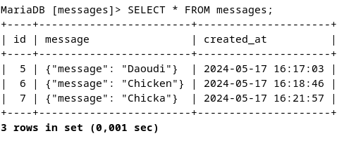

pip install django

django-admin startproject mysite
cd mysite

python3 manage.py runserver

cd /home/toto/mysite
cd /home/toto/mysite/messages_app/templates/messages_app
python manage.py startapp messages_app

http://127.0.0.1:8000/

/home/toto/mysite/messages_app/templates/messages_app

